6A^{th} Grade: Unit 12, Lesson 7

- Complete the following percent of change formula by filling in the missing operation
$$\frac{final value ? initial value}{initial value}×100$$

-

- What is a percentage of change?

It is the difference between a final value and an initial value and it is expressed as a percentage of the initial value.

- A theatre decreased the number of people allowed at the same time by 40%. Previously it allowed 250 people at the same time. What is the number allowed with a reduction of 40%?
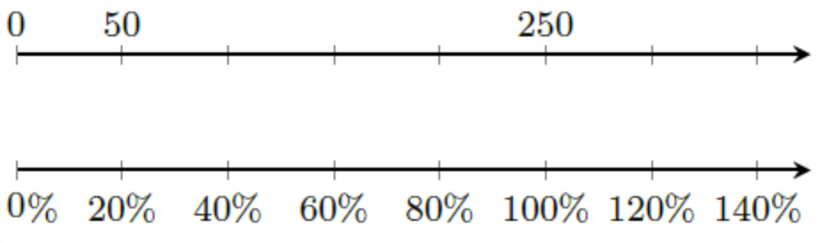

150 people

